 | SCHOOL OF NATURAL APPLIED SCIENCE

DEPARTMENT OF COMPUTER SCIENCE AND INFORMATION TECHNOLOGY (CSIT)

PROJECT (NPRJ63030)

ICT DIPLOMA THIRD YEARS– 2023

SUPERVISOR: DR TITE TUYIKEZE

COVER PAGE: CONTENTS AND LAYOUT

SCHOOL OF NATURAL APPLIED SCINECE

Name of Document:

Final Document

Name of the System

Student Management System(AcademixHub)

Group Names

 | Student Number | Surname | First Name
1 | 202210721 | Mbatha | Gift
2 | 202207257 | Moleko | Nthabeleng
3 | 202209731 | Choche | Rethabile
4 | 2022327251 | Thebe | Lehlohonolo
5

…………………………………………………………………………………………………………………….

Submission Date: 12 March 2024

Table of Contents
PHASE 1
Problem statement 4
Introduction 4
Business and ICT aspects 4
Identification of ICT problems………………………………………………………………………………………………………..6
Interview With HOD of Crestview University 6
Problems Identified from Interview 7
Daily Transactions 8
System Requirements Analysis 9
Importance of the Student management system 10
Solution Analysis 10
Conclusion……………………………………………………………………………………………………………………………………..11
Interview with a group member 11

PHASE 2

System Functional and Non-functional Requirements 12
Non-functional 12
Functional 13
System Modelling……………………………………………………………………………………………………………………….14
Context diagram…………………………………………………………………………………………………………………..….…….14
Architectural design………………………………………………..………………………..………………….………………….…15
Client-server model….………………………………………….…………………………………………………….………………..…16
System design models…………………………………………………………..……………………………………….……….….17
Use case diagram…………………………………………………………………………………………………………………….…...17
Activity diagram……………………………………………………………………………………………………………………….…...18
State diagram…………………………………………………………………………………………………………………………...….19
Class diagram...………………………………………………………………………………………………………………..…..……..20
Sequence diagram………………………….………………………………………………………………..…………………………..21 Project Management…………………………………………………………………………………………………………………..22
Work breakdown…………………….………………………………………………………..……………………………………….....22
Gantt chart………………………………………………………………………………………………….……………………………….23

PHASE 3
Graphical user interface design 24
Welcome page………………………………………….……………………………………………………………………………………24
Role webpage………………………………..……….………………………………………………………………………………….…24
Sign in page………………………………………………………………………………………………………………………………..…25
Sign up page………………………………………….………………………………………………………………………………………25
Administrators’ webpages………………..………………….………………………………………………………………………….26
Lecturers’ webpage 29
Student webpage……………………………………………………………………………………………………………………………33
Database design 37
Database tables 37

PHASE 1:

Problem statement
Introduction
Educational institutions, from primary schools to universities, face increasing challenges in managing student data, academic records, and various administrative processes. Traditional management methods, which often rely on paper-based systems and isolated digital tools, lead to inefficiencies, errors, and delays. These shortcomings negatively impact the productivity of staff, the accuracy of student records, and the overall experience of students, lecturers, and administrators. As education becomes more complex and demands for timely, accurate information grow, the need for a more efficient system becomes evident. The student management system is a software designed to streamline and automate various administrative and academic processes within educational institutions. Our system aims to improve efficiency, accuracy, and accessibility in managing student-related information, academic records, and administrative tasks. Crestview University is implementing a student management system (SMS).

Business Context
Though it is 3 years old, Crestview University is considered a newly established institution. It has been gaining recognition from around the region and abroad, this has led to the application and acceptance of many students and ultimately, the increase of administrative workload. It has been challenging for administrators to manage students’ records, grades, communication, and attendance considering the rapidly increasing number of students. The institution came to realize that an action has to be taken that will help with efficient administration, communication, and other operations.

System Selection
A detailed and rigorous research Is conducted by the administration and some of the school board to select the best suited system whilst considering the school’s goals and requirements. Factors such as user interfaces, experience, scalability customization options and integration and integration competence with existing infrastructure.

Infrastructure Upgrade
The current infrastructure will be evaluated by a group of ICT individuals to make sure that it aligns with the new system’s requirements. The process of upgrading or updating system components maybe involved it this evaluation.

Software Implementation
To ensure that the system will accommodate everyone the ICT team will work hand in hand with various members of the institution to ensure that the system accommodates even those with special needs as there might be users with different needs.

Security measures
The ICT team implements robust security measures to protect confidential student information stored within the system, including encryption protocols, security audits, access control and compliance with regulations of data protection.

Adaption by users
The ICT team encourages the use of the new system among students, administrator, and lecturers to ensure the system is widely used, adopted, and accepted. They encourage feedback and address any usability issues.

In summary, the student management system utilizes a holistic approach to ICT usage, touching on various administrative and academic needs while ensuring data security, accessibility, and compliance with regulatory requirements.

Interview with the Head of Department (HOD) of Crestview University about partnering with the Student Management System (AcademixHub).

Developer: Good morning! Thank you for having me.

HOD: Great, it's good to have you here.

Developer: So, we're considering improving your current system here at your university. Could you share your thoughts on this potential partnership?

HOD: I think teaming up with you for a student management system could help our department, improving our workflow.

Developer: What specific advantages do you see from this partnership?

HOD: For starters, it would strengthen our curriculum management, making it easier to access and change lesson plans, syllabi, and teaching resources. This would enhance consistency and save the time spent searching for materials across many platforms.

Developer: How do you expect the system to assist with teacher assignments and evaluations?

HOD: Automating lecturer assignments and evaluations would be a game-changer, eliminating manual tracking and paperwork, reducing errors and delays.

Developer: How about student assessment and tracking?

HOD: A student management system might significantly increase our ability to monitor student development and keep accurate records. Automated attendance monitoring, online grading, and progress reporting would speed up these processes while maintaining data security.

Developer: And how do you expect communication to be impacted?

HOD: Messaging, announcements, and online portals would allow for more timely and effective communication, resulting in more participation and cooperation. And I believe the system could enhance our communication channels.

Developer: Are there any problems or obstacles you see with this collaboration?

HOD: One problem would be to ensure that staff workers receive proper training and assistance to efficiently use the system. Resistance to change is also a possible issue, therefore clear communication and continued support are essential for effective adoption.

Interviewer: Thank you for providing this information. Collaboration with a student management system appears to provide considerable benefits in terms of centralizing curriculum administration, automating instructor assignments and evaluations, improving student assessment procedures, and improving communication channels. Would you agree?"

HOD: Absolutely. I feel that this collaboration can address many of the difficulties we meet while also increasing our department's overall efficiency and effectiveness.

Problems identified from the interview.
1. Scattered documents across platforms complicate curriculum management.
2. Manual lecturer assignments and evaluations consume time.
3. Tracking student progress and maintaining accurate records is challenging.
4. Communication channels are inefficient, causing delays.

Daily Transactions of the Student Management System and potential problems that may arise.

 | Daily Transactions | Problems
Student Registration | Students register for courses, and they provide personal information. | Incorrect or incomplete registration data may cause errors in student records.
Attendance Tracking | Lectures record class attendance for each session. | Lectures use manual attendance tracking, which may lead to inaccurate attendance records.
Class Scheduling and Assignments | Administrators schedule and assign classes to a specific lecture. Lectures also upload homework and projects to students. | Scheduling errors may arise, and this may confuse students and lecturers regarding homework and assignment deadlines.
Grading | Assignments, quizzes, and exams need to be graded by lectures by entering scores into the student management system. | Inconsistent grading practices might impact students’ academic progress.

System requirements analysis

In this modern educational landscape, a comprehensive student management system is essential. The student management system serves as the backbone of administrative operations within educational institutions, facilitating efficient management of student data, communication channels, and academic processes.

Here are the key reasons why a student management system is essential:

Centralized Data Management
Higher educational institutions deal with large amounts of data, including personal information, attendance records, academic records, and more. This system provides a centralized database, for storing, organizing, and accessing data.

Enhanced Communication Channels
Having effective communication between students, teachers, and administrators is very important for the institution’s success. This student management system offers tools like messaging, announcements, and portals, enabling seamless communication.

Improved Student Performance Monitoring
It is very important to track student performance to identify areas of improvement. A student management system will provide features for tracking grades, assignments, and assessments which will allow lectures to monitor student progress effectively.

Data-Driven Decision Making
Educational institutions make decisions regarding curriculum planning, resource allocation and strategic initiatives based on access to comprehensive student data. The system provides reporting and analytics features, empowering administrators, and educators with actionable insights to improve educational outcomes.

Compliance with regulations
Institutions must adhere to regulations and standards related to security, data privacy and reporting. The system helps to ensure compliance with regulations such as GDPR, FERPA, and others by implementing robust security measures, data encryption and audit trails.

Adaptability and scalability
Institutions vary in size, structure, and requirements. The student management system should be adaptable and scalable to accommodate the unique needs and growth trajectories of different institutions, whether small or large schools or universities, or online learning platforms.

Solution analysis

Problem 1: Scattered documents across platforms complicate curriculum management.

Solution: A centralized document management feature within the student management system should be developed so that the administrators and lectures can upload, organize, and access curriculum documents such as lesson plans, syllabi, and teaching material in a single platform. To ensure data security and consistency implement version control and access permissions.

Problem 2: Time is wasted by manual lecture assignments and evaluations.

Solution: An automated module evaluation within the student management system. This will increase the process of assigning teachers to classes based on qualifications and availability. Introduce standardized evaluation criteria and digital evaluation forms to automate the evaluation process to save time.

Problem 3: Tracking student progress and maintaining accurate records is challenging.

Solution: Increase student progress tracking and record-keeping features in the student management system. Automated attendance tracking for accurate student attendance. Online grading and assessment tools. Customizable dashboards and reports for monitoring student progress in real time.

Problem 4: Communication Channels are Inefficient, Causing Delays

Solution: Handle communication between stakeholders by introducing communication tools in the student management system. The system should have messaging capabilities such as discussion forums and messaging systems to achieve seamless communication channels.

Problem 5: Staff Training and Resistance to Change are Concerns During Implementation

Solution: To ensure that the staff understand and know how to operate the system they will have to be familiar with using it by having a series of programs that will educate them. Both online and in physical training sessions should be implemented based on the roles and responsibilities of the staff members. To help the staff get used to the system, support and necessary resources must be offered to them, it will also foster a habit of continuous learning in the organization.

The given solutions can help mitigate problems like those. Not only can educational institutions improve their systems functionality by applying these solutions, but they will also improve their efficiency and effectiveness which will improve the overall user experience.

Conclusion

The current student management system is faced with several challenges:
scattered documents complicate curriculum management, manual teacher assignments consume time, inefficient communication channels causing delays, difficulties in tracking student progress and concerns about staff training and resistance to change arise during implementation.
To address these issues, a centralized document management system feature can unify curriculum documents, while automated modules for teacher assignments and evaluations can streamline administrative tasks. Enhancing progress tracking and record keeping features will accuracy, and integrating communication tools directly into the system will facilitate seamless communication. Additionally, comprehensive training programs can address staff training needs and mitigate resistance to change. These solutions aim to enhance efficiency, communication, and overall effectiveness in managing student data and academic activities within educational institutions.

Interview with a group member.

Gift: What do you think about this project?
Nthabeleng: It looks like a very complex project, but it seems like it is going to be fun building this system.
Gift: Yes indeed, what do you think might be the issue while building this system?
Nthabeleng: Time! As much as we have all the resources we need to build this system, I think time might be the issue, so we need to use time effectively.
Gift: What can we do as a team to ensure that we deliver a reliable system?
Nthabeleng: follow our documentation and we have to make sure we deliver everything that is mentioned in the document, and we should follow all the software engineering principles.

Phase 2:

Non-functional
- Reliability
The system should ensure that it delivers services as specified to minimize downtime and errors, providing uninterrupted access to critical functionalities.
- Availability
The system should be available 24/7 to accommodate users’ needs at any time, especially during peak usage periods such as registration or grade submission deadlines.
- Security
To avoid unauthorized access, all sensitive data, including as student records, grades, and personal information, should be encrypted both in transit and at rest.
Role-based access management ensures that only authorized employees have access to system capabilities and data based on their roles (e.g., administrator, teacher, student).
Verify users' identities before granting them access through authentication and authorization. Authorization mechanisms should ensure that users only have access to the data and capabilities that they are granted.
- Maintainability
Modularity: Design the system in a modular way, with well-defined components and interfaces, to facilitate easier maintenance and future enhancements.
Documentation: Provide detailed documentation on system architecture, design, codebase, and usage instructions to help developers, administrators, and users understand and manage the system.
- Portability
The System should be able to operate on any device and operating system, this is to ensure accessibility for users across different environments.
The system should be compatible with web browsers, and mobile responsiveness across different operating systems.
- Performance
The system should have the best performance to handle system user interactions that are occurring at the same time, respond fast to user requests and process large amounts of data fast.
The systems performance should be measured not only through the system’s scalability but also through throughput and response time for common task such as loading student records or generating reports.

Functional

- Student Registration
- The system shall allow students to register for courses.
- The system shall capture and store student information, including personal details.
- Class scheduling
- The system shall enable administrators to create and manage class schedules for different courses.
- The system shall enable administrators to assign lecturers to classes.
- Attendance tracking
- The system shall allow the lecturers to record student attendance for each lesson.
- Grading and assessments
- The system shall allow lecturers to grade assignments, exams, and quizzes.
- It shall calculate the students' overall grades based on the weight of the assessments.
- Communication Tools
- The system shall provide communication between lecturers, admins, and students.
- The system shall allow the lecturers and the administrator to make announcements for important events, announcements, and deadlines.
- Student Progress Monitoring
- The system shall allow the lecturer to monitor student progress and performance during the academic year.
- The system shall generate progress reports for students for all the modules.

System Modelling

Context Diagram
This diagram provides an overview of the student management system’s scope and its interactions with key stakeholders. It helps understand the system’s boundaries and main functionalities.

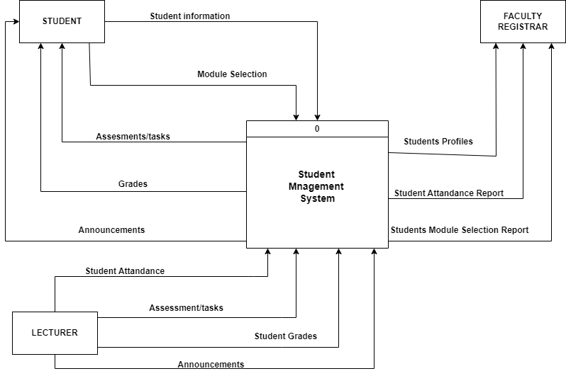

Figure 1.1

Architectural design

Client-side Components
- User Interface
The UI component is made up of the graphical interface that users interact with. Responsibilities include presenting information to users, collecting their inputs, and displaying data.
- Client Application
This component represents the software application that is running on the client’s device. This includes handling user interactions, formatting data for displaying, and sending requests to the server.

Server-side Components
- Application Servers
The application servers are made up of Three servers, namely File Server, User Information Server, and Web Server. These servers host the core logic and functionalities of the system. Their responsibilities include processing client requests, executing business rules, and managing data.
- Database
The Main database stores and manages the system’s data. Its responsibility is to store and retrieve data, ensure data integrity, and handle concurrent access. The backup database backups the data just in case there is a fault with the data.

Interactions
- The Client UI interacts with the Client Application to present the user interface and capture user inputs.
- The Client Application sends requests to the Application Server to perform various operations such as user authentication, data retrieval, and updates.
- The Application Server processes client requests, executes business logic, and communicates with the Database Server to retrieve or update data.
- The Database Server stores and retrieves data as requested by the Application Server, ensuring data consistency and integrity.

client-server model
This model demonstrates a typical setup for an institution, where multiple users need access to various services and data. This architecture allows for centralized data management, data redundancy and backup, distributed access for different user groups, scalability and modularity in system design.
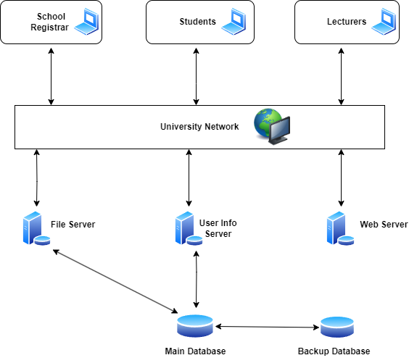

Figure 1.2

System design models
Use case diagram
This diagram illustrates the interaction between users and the system, showing all activities that are performed in the system by the users.

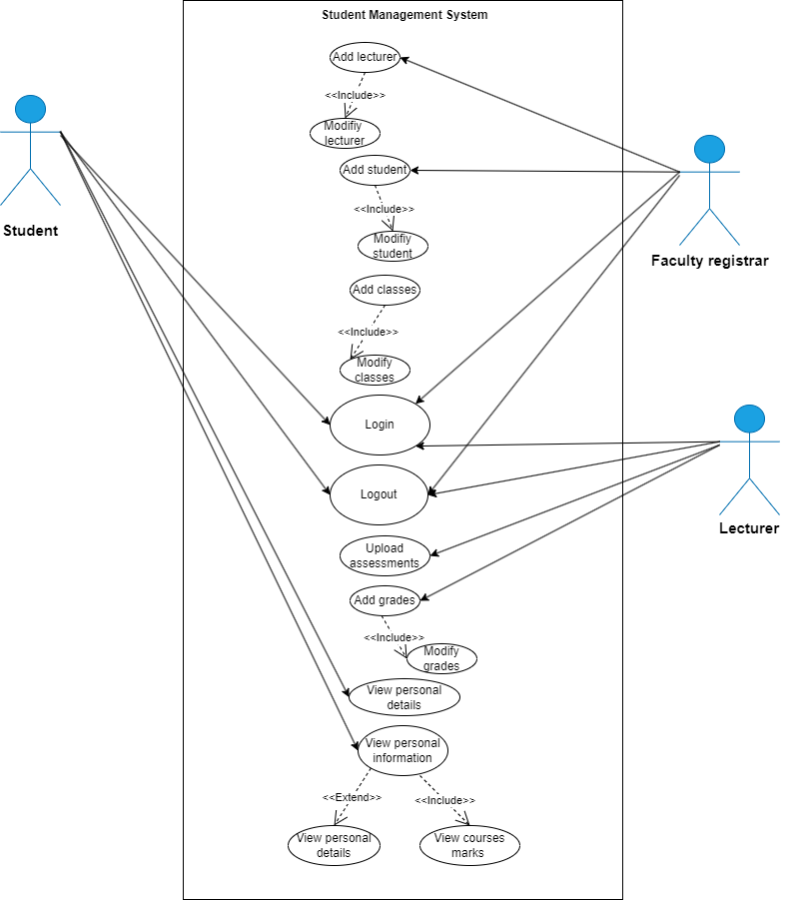

Figure 1.3

Activity diagram
This diagram shows the processes of a student registering for a course.
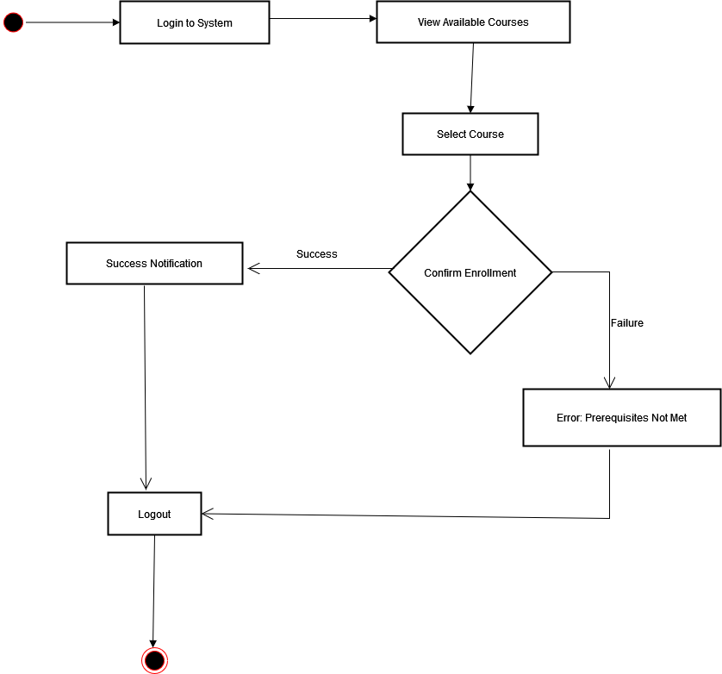

Figure 1.4

State diagram
The diagram illustrates the basic flow of a user authentication process, including error handling and the main application state, the dashboard after successful login.

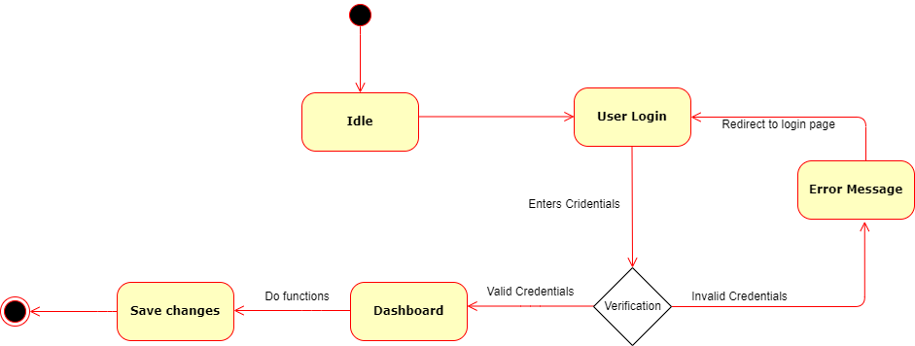

Figure 1.5

Class diagram

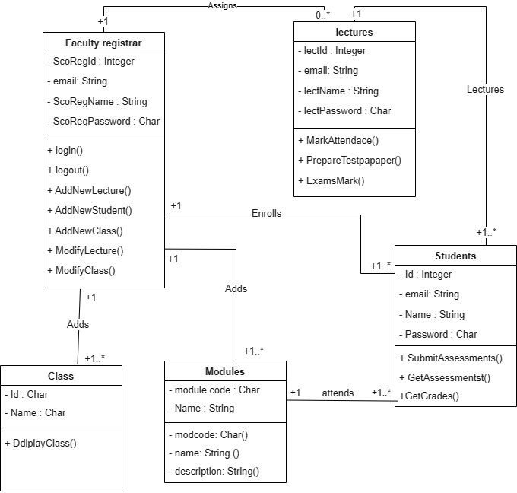

Figure 1.6

Sequence diagram
This diagram helps visualize the flow of information and responsibilities between different roles in the educational system. Showing how processes are initiated and completed across different entities.
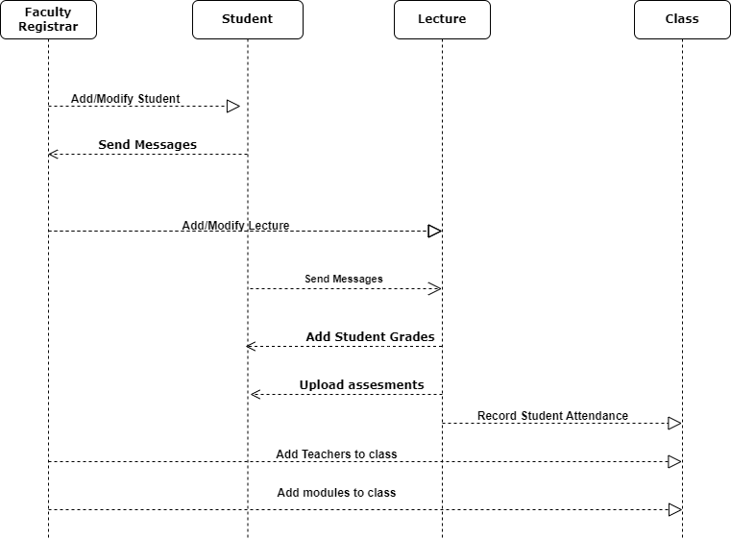

Figure 1.7

Project Management
A work breakdown table

Tasks | Deliverables | Milestones | Resources needed | Dependencies and constraints | Risk and contingencies
Requirements gathering and analysis | Requirements document | Completion of requirements gathering phase | Project manager, business analysts | Availability of stakeholders for interviews and meetings | Incomplete requirements may lead to requirements creep
System design | System architecture  Database schema | Approval of system design by the stakeholders | System Architects, database administrators | Understanding of system requirements | Any changes in system requirements may impact system design
UI design and development | UI prototype, user interface components | Completion of UI prototype | UI designers, frontend developers | Clear understanding of user requirements, compatibility on various devices and browsers | Changes in user requirements may impact UI design, regular feedback sessions with stakeholders
Backend development | Application logic, database integration | Completion of core functionalities | Backend developers, database administrators | Finalization of system design and database schema | Technical challenges in performance; regular testing and debugging
System testing | Test plans, test cases, and bug reports | Completion of testing phase, approval for development | Quality Assurance engineers, testing tools | Availability of test environments, thorough testing of all functionalities | Undetected bugs or issues; comprehensive regression testing and bug testing
Deployment and implementation | Deployed system | Successful deployment and user acceptance | System administrators | Completion of testing phase | Deployment issues or disruptions; backup plans in case of unforeseen issues
User training | Trained users, user feedback | Completion of training sessions, user satisfaction | Training instructors, user documentation | Availability of user for training sessions | Resistance to user adoption; ongoing support and communication to address
System maintenance | System bugs, bug fixes | Establishment of support processes | team, developers | Documentation of system functionalities | Technical issues or system downtime

Gantt chart

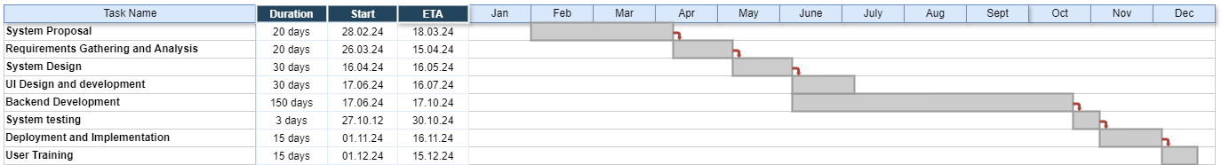

Phase 3:
Graphical user interface design

- This is the welcome page to the university website. To proceed to the next page, you click on the “Get Started” button.
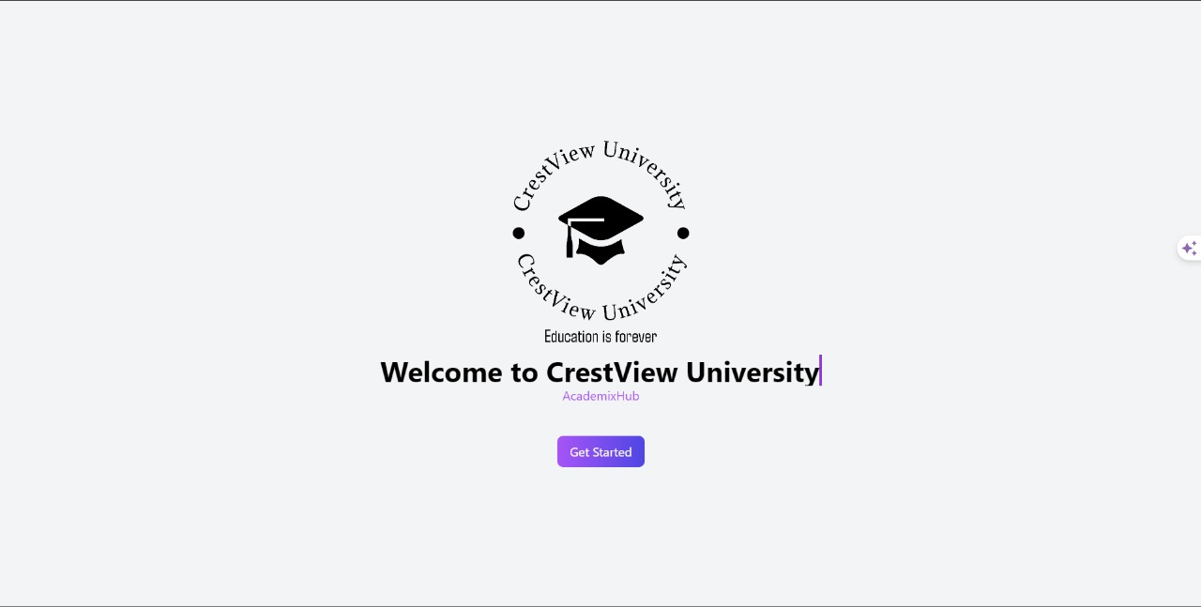

- This is the webpage which appears after a user clicks the “Get Started” button on the welcome page. On this page a user is required to select their role in order to proceed to the next page of the website.
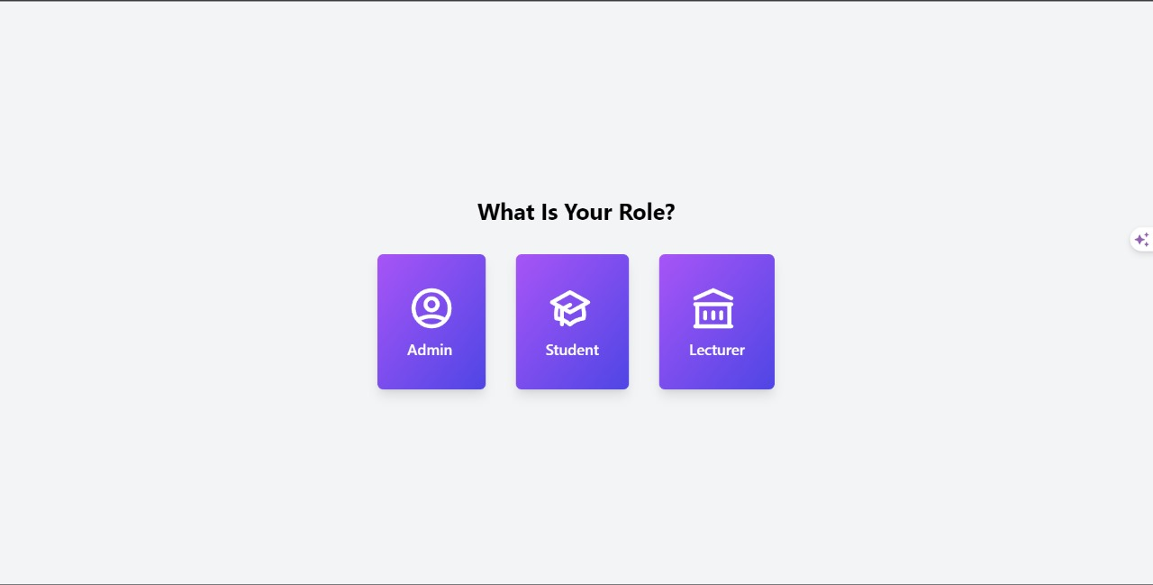

- After the user selects their role on the website, the system redirects them to the “Sign in” page where they are required to sign in using their credentials.
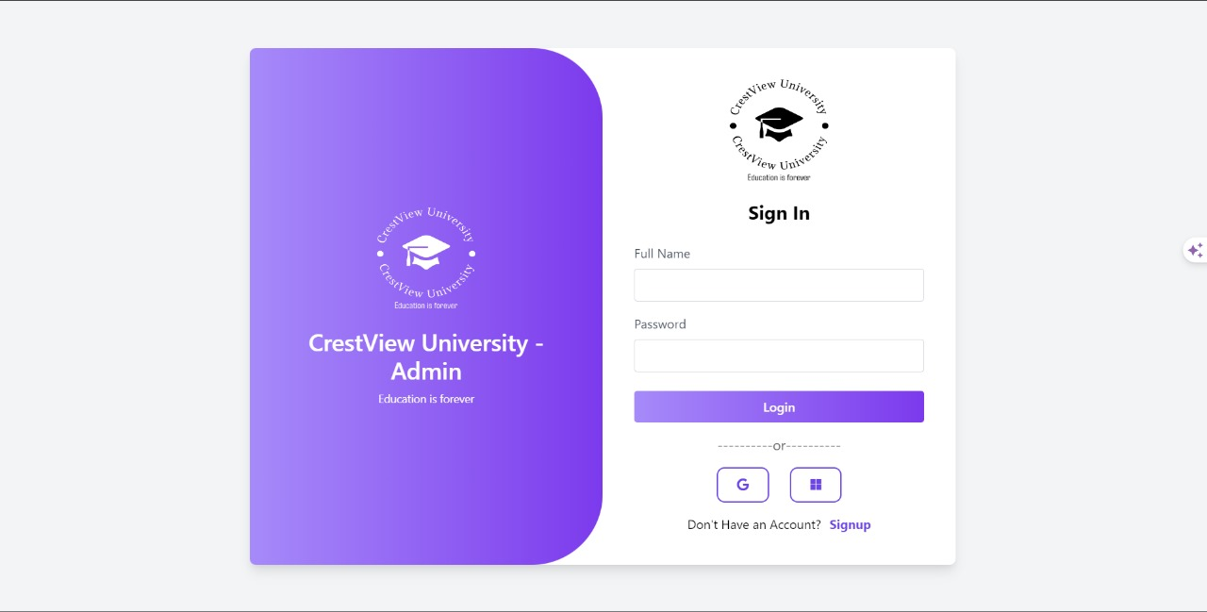

- This the sign up page where the user signs up if they do not have their details captured already.
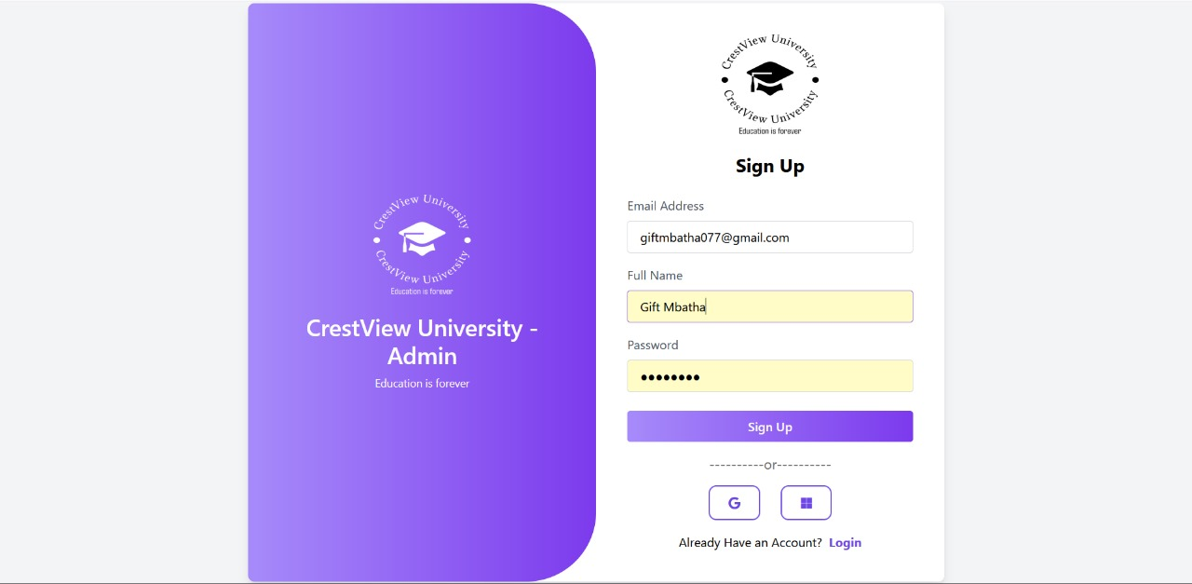

Administrator

- This is the administrator dashboard after they have signed in successfully.
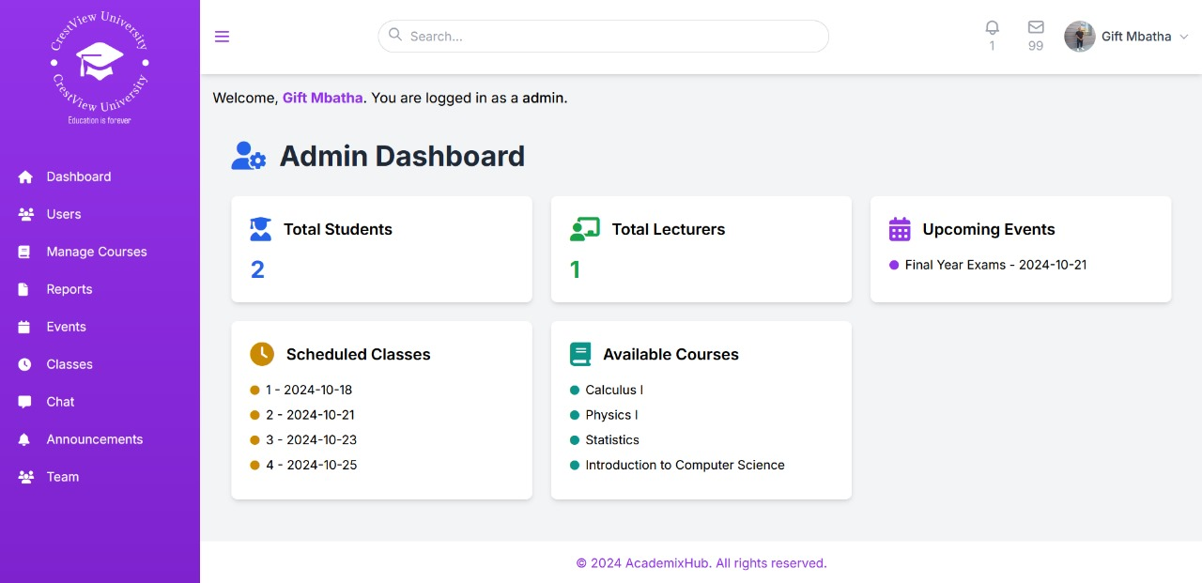

- This is where the administrator gets to manage users of the system, it also shows a list of the users who are already captured.
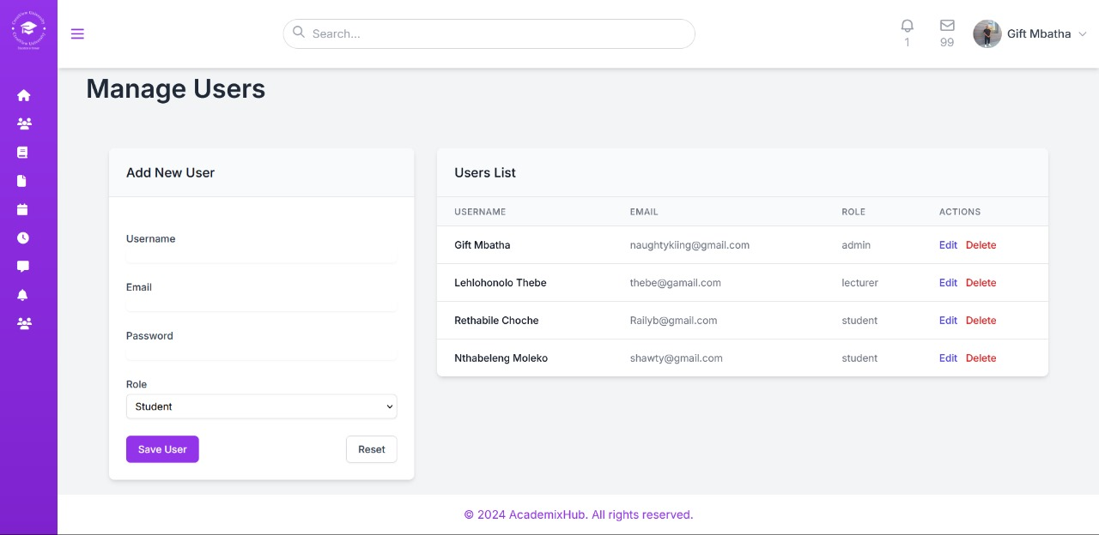

- On this page, the administrator manages the courses, and a list of the courses is displayed.
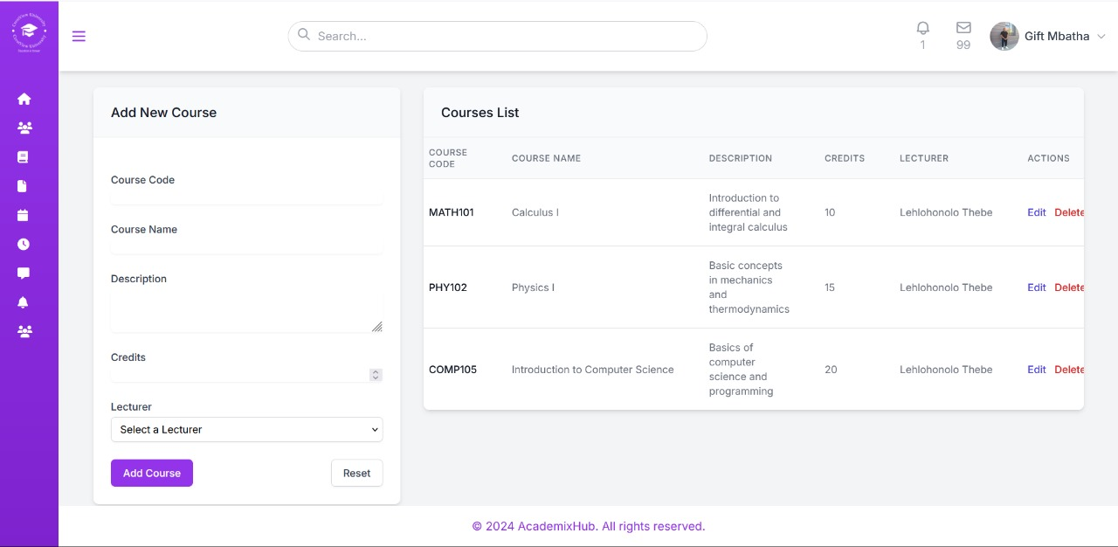

- This is where the administrator manages and adds upcoming events.
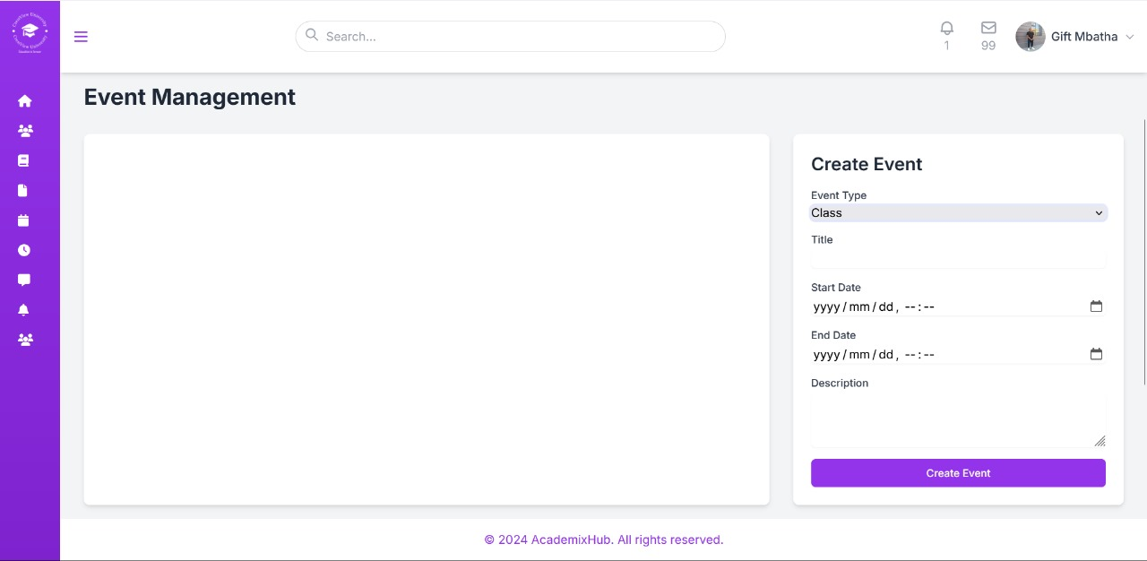

- On this page, the administrator can schedule classes for students and lecturers.
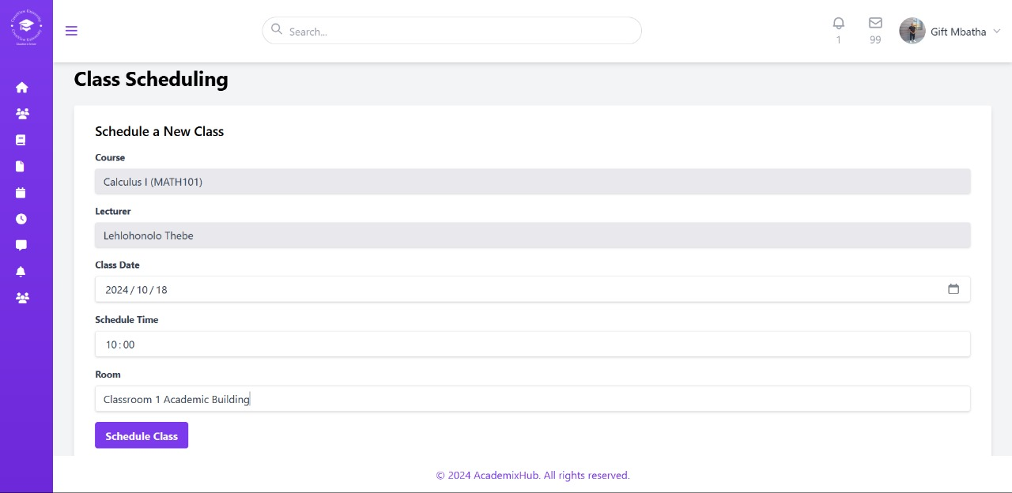

- This is where the lecturers and the administrator make important announcements , reminder on events, and deadlines.
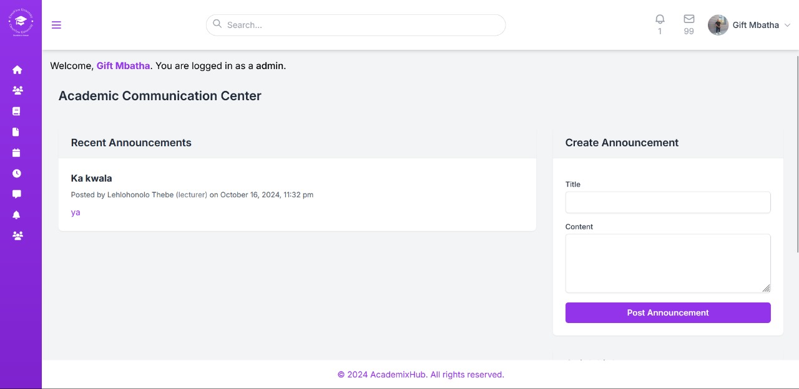

- The admin can view and download the university reports as a pdf document.
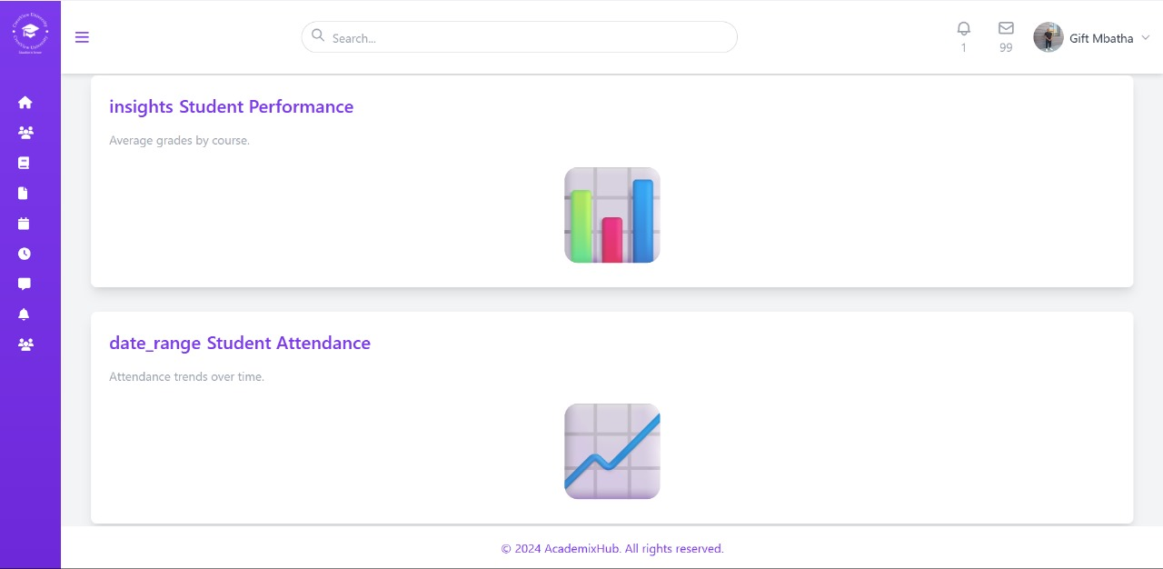

Lecturer

- This is the lecturer’s dashboard, which shows the overview of what the lecturer can do on the lecturers dashboard.
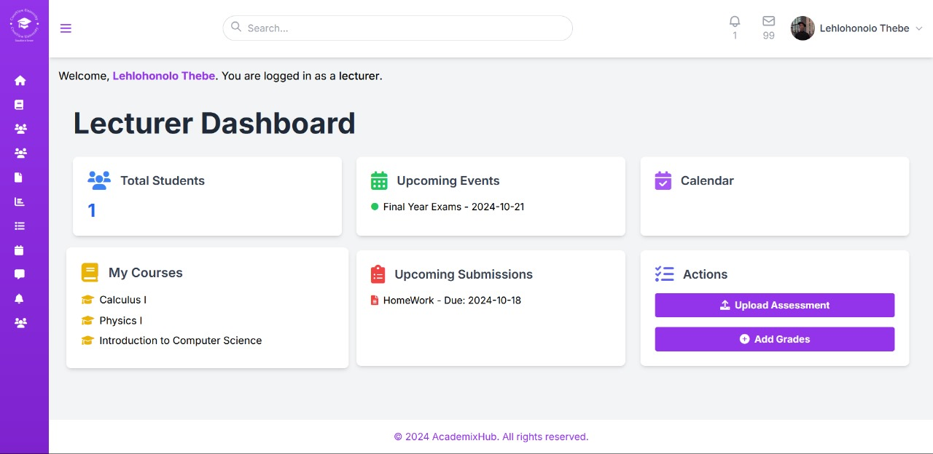

- This page shows the courses that the lecturer is teaching and the assessments.
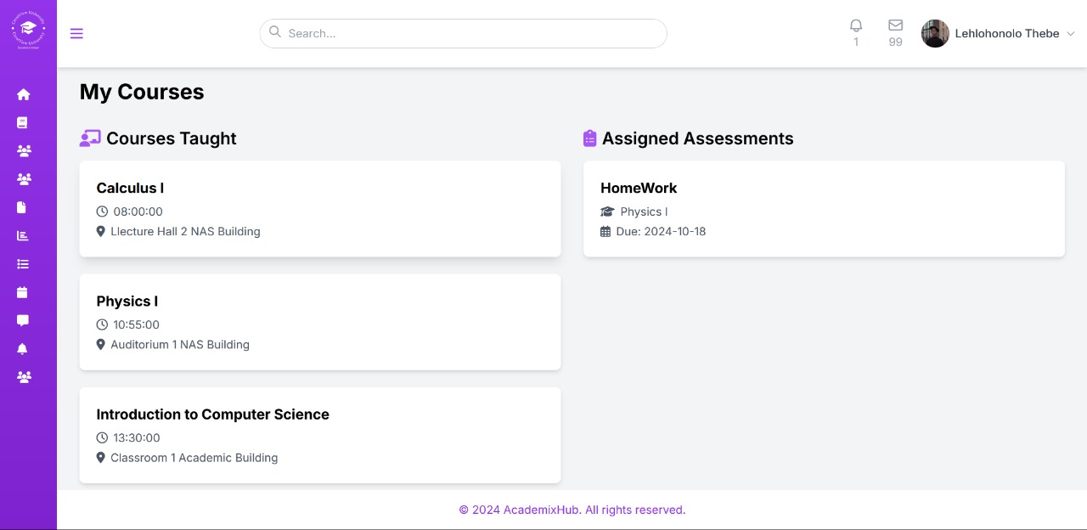

- This is where the lecturer views the list of students they teach for a specific course.
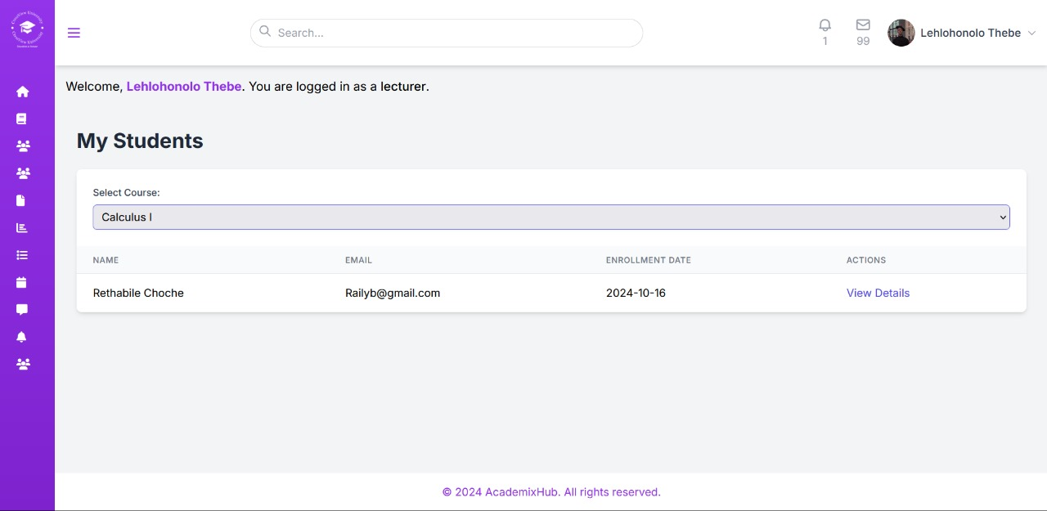

- This is where the lecturer is allowed to monitor student progress and performance during the academic year.
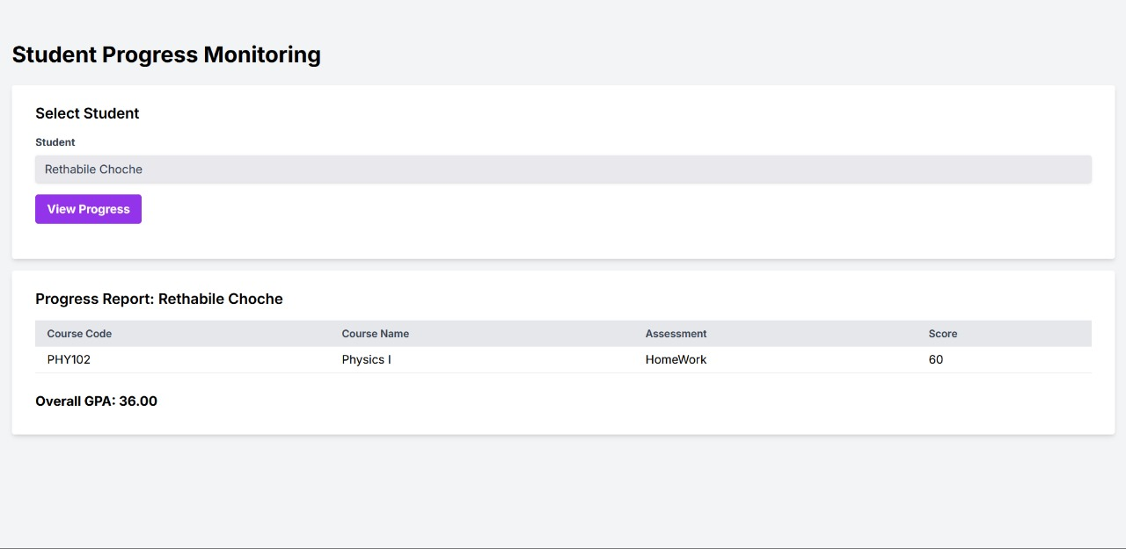

- Using this page, the lecturer can upload assessments for students, for a specific course.
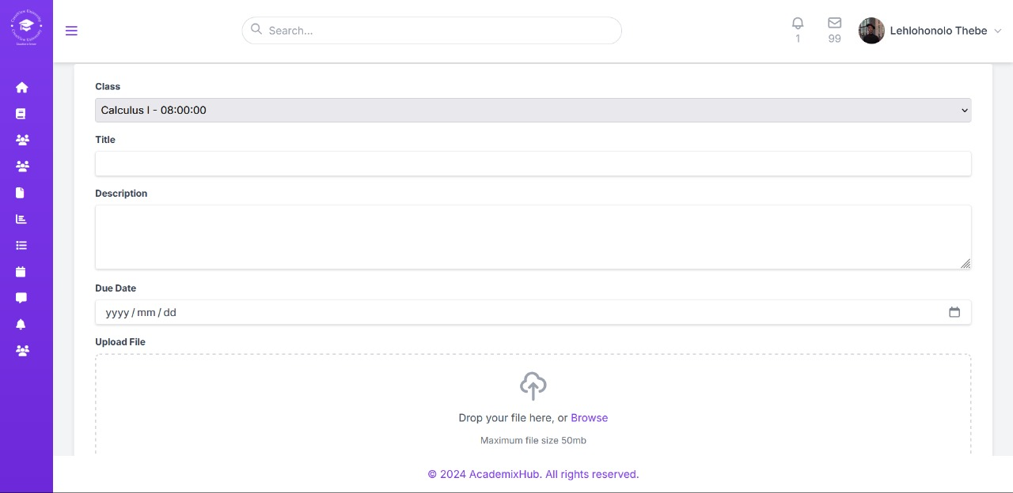

- The lecturer gets to grade the students’ assessments on this page.
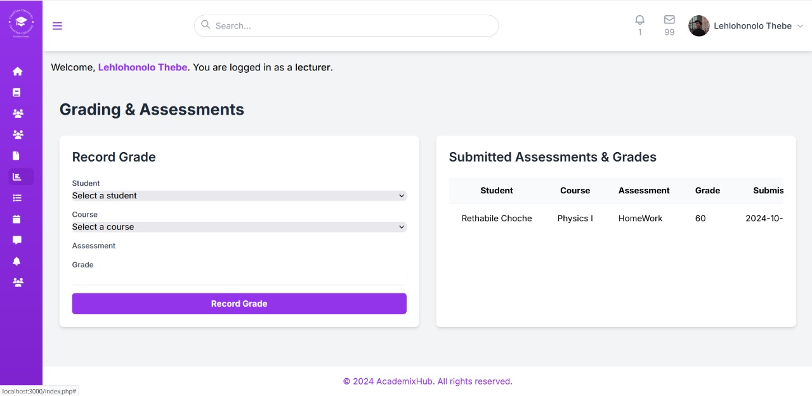

- This allows the lecturers to record student attendance for each class.
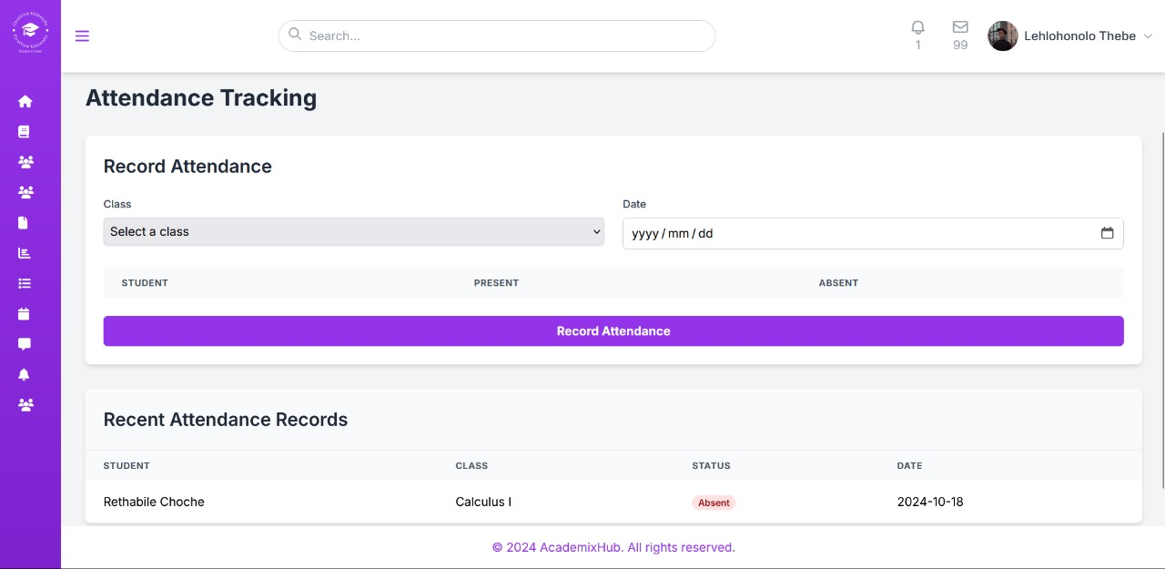

Student
- This is the students dashboard.
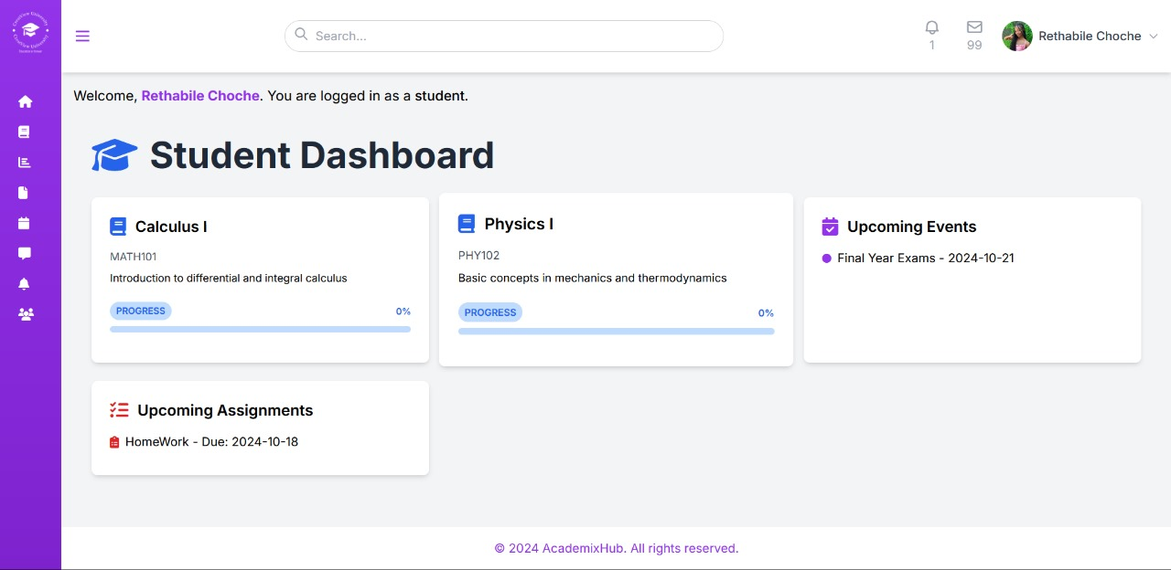

- This page shows the student the courses they are enrolled in, and assessments them must complete.
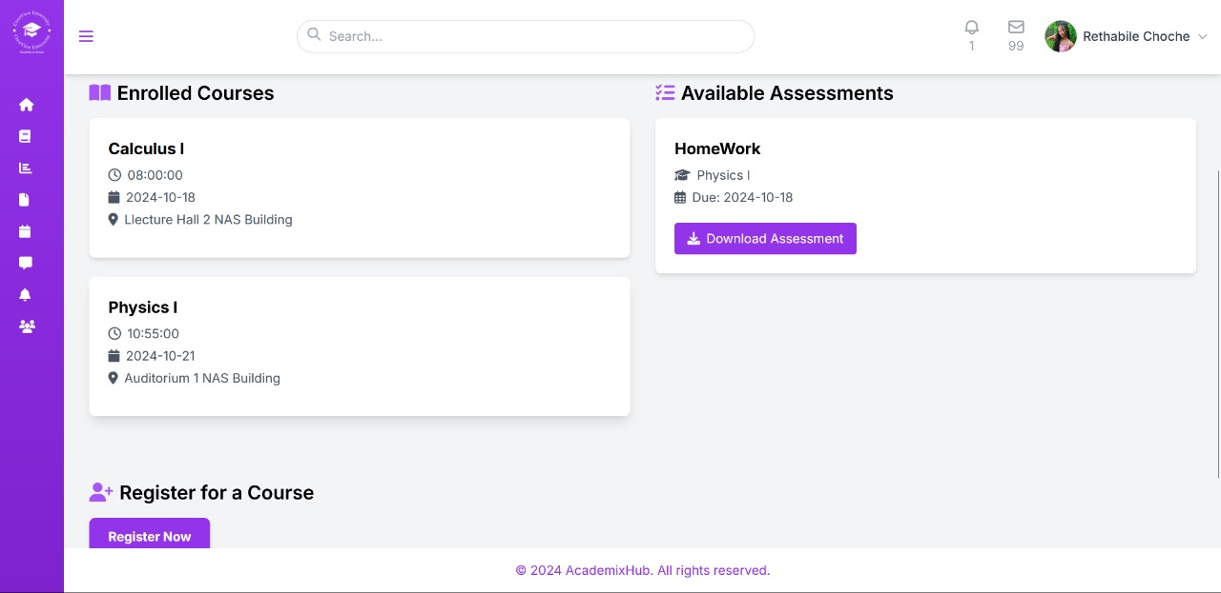

- On this page, the students are able to monitor their progress and download their progress report for all the courses.
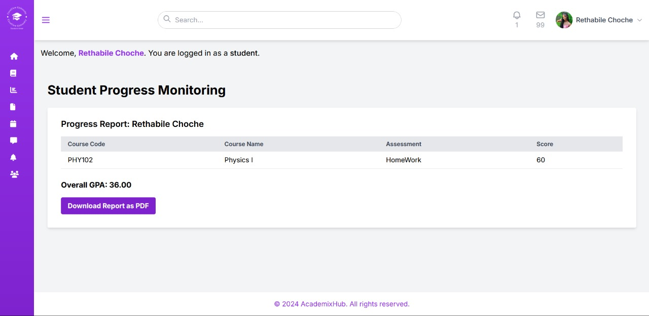

- Students are able to upload from their computers and submit their assessments on this portal.
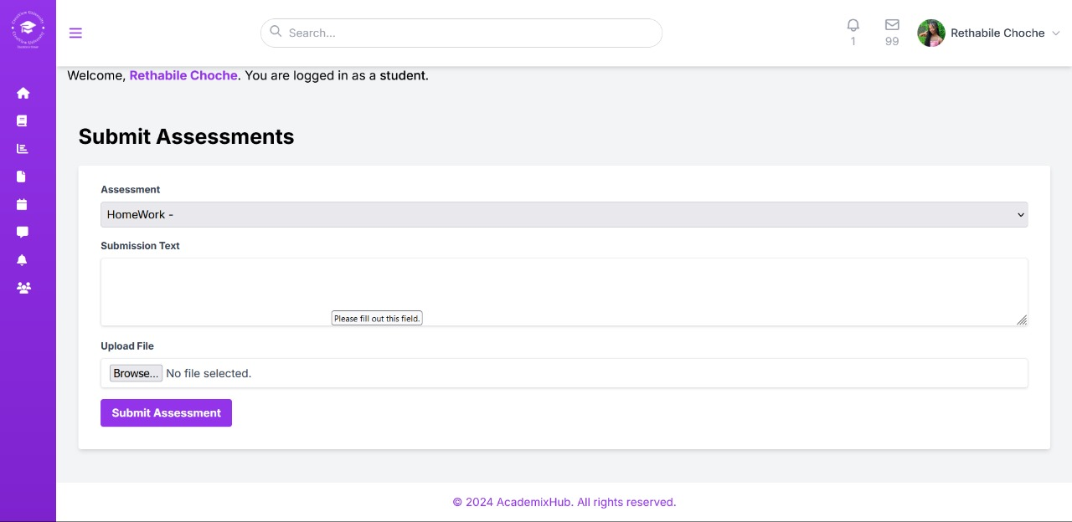

- In this page the student are able to receive and see the important announcements sent by the lecturer or the administrator.
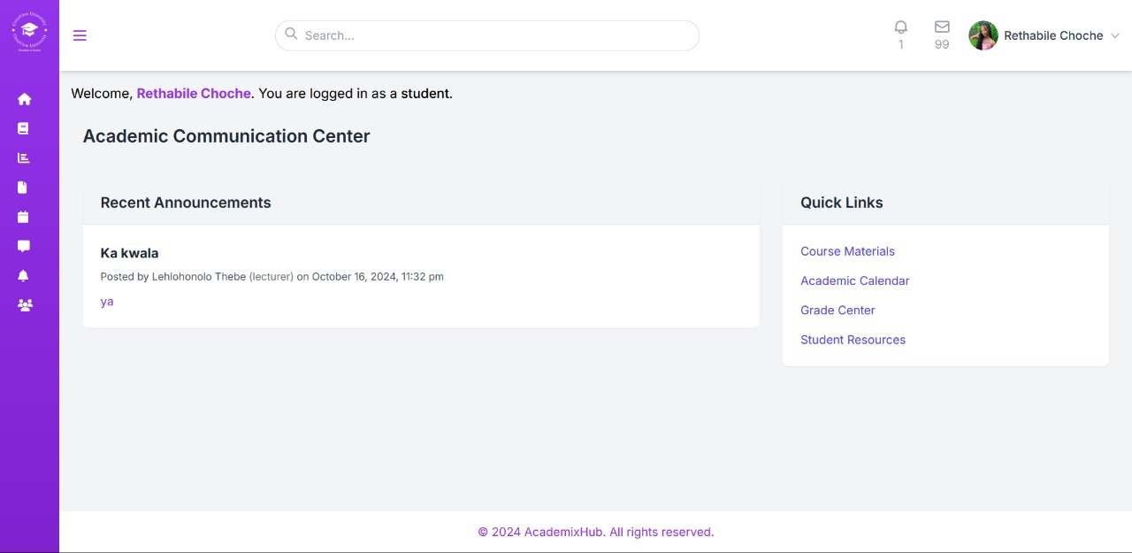

- This page is going to be visible on all the users, it shows the upcoming events and the calendar.
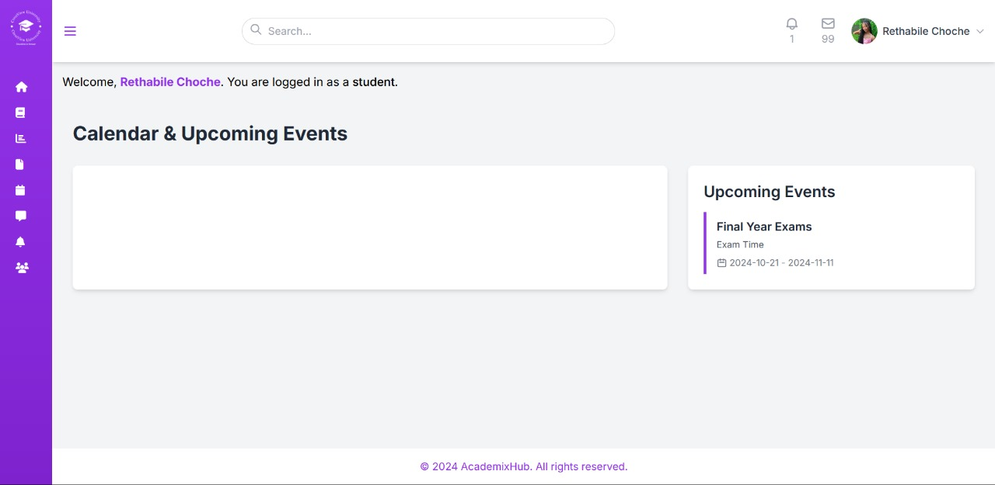

User profile
- All the users will be able to edit their profile.
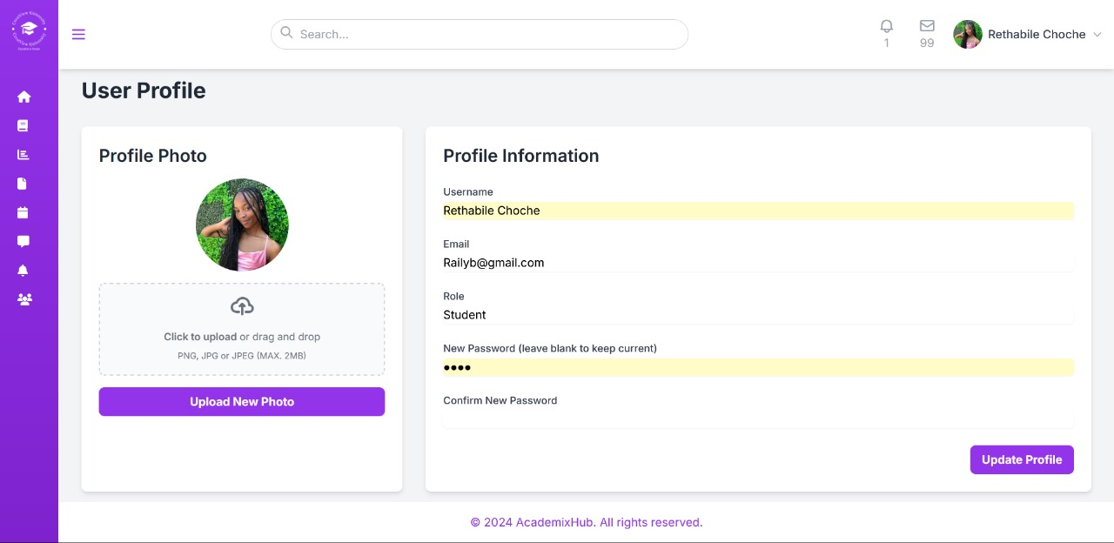

26.Unified communication channel to establish communication between lecturers, admins, and students.
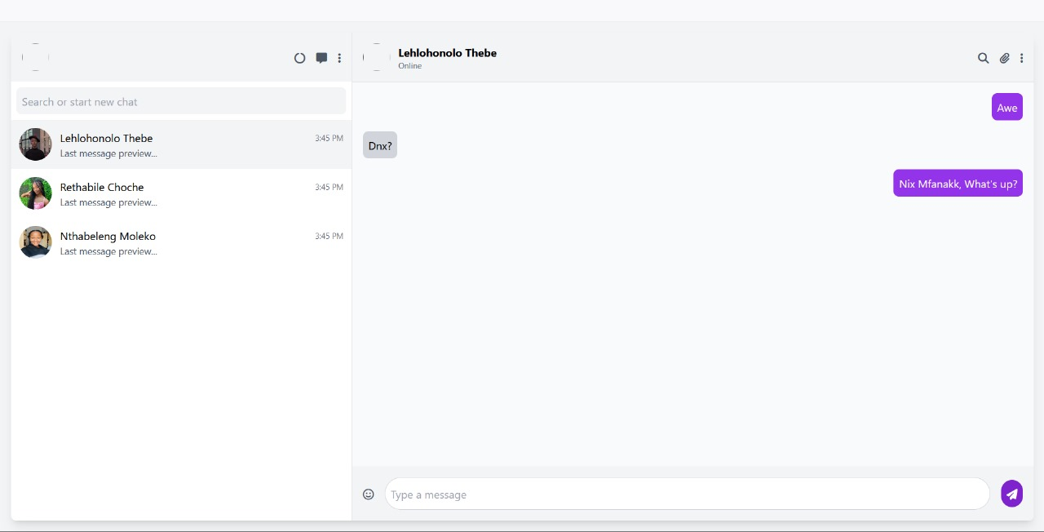

Database design

Users table:
Attributes | Type | Size | Description
User_id | Integer |  | Primary key
Username | Varchar | 255
password | Varchar | 255
Email | Varchar | 255
Role | Varchar | 10
Profile_photo | Varchar | 255
Created_at | timestamp

Events table:
Attributes | Type | Size | Description
Event_id | Integer |  | Primary key
Title | Varchar | 255
description | text
Start_date | Date
End_date | Date | 10

Courses table:
Attributes | Type | Size | Description
Course_id | Integer |  | Primary key
Course_code | Varchar | 20
Couse_name | Varchar | 255
description | Text
credits | Integer

Classes table:
Attributes | Type | Size | Description
Class_id | Integer |  | Primary key
Course_id | Integer |  | Foreign key
Lecturer_id | Integer |  | Foreign key
Schedule_time | Time
Room | Varchar | 50

Enrollments table
Attributes | Type | Size | Description
Enrollment_id | Integer |  | Primary key
Student_id | Integer |  | Foreign key
Course_id | Integer |  | Foreign key
Progress | Integer

Assessments table
Attributes | Type | Size | Description
Assessment_id | Integer |  | Primary key
Class_id | integer |  | Foreign key
title | Varchar | 255
Due_date | Date
Gender | Varchar | 10

Communications table
Attributes | Type | Size | Description
Communication_id | Integer |  | Primary key
Sender_id | Integer |  | Foreign key
Recipient_id | Integer |  | Foreign key
message | Text
Sent_at | Datetime | 10

Attendance table
Attributes | Type | Size | Description
Attendance_id | Integer |  | Primary key
Student_id | Integer |  | Foreign key
Class_id | Integer |  | Foreign key
Status | Varchar | 10

Grades table
Attributes | Type | Size | Description
Grade_id | Integer |  | Primary key
Student_id | Integer |  | Foreign key
Class_id | Integer |  | Foreign key
Grade | Varchar | 10

Chats table
Attributes | Type | Size | Description
Chat_id | Integer |  | Primary key
Name | Varchar | 100
Created_at | timestamp

Chat member’s table
Attributes | Type | Size | Description
Id | Integer |  | Primary key
Chat_id | Integer |  | Foreign key
user_id | Integer |  | Foreign key
Message | Text
Sent_at | timestamp

Messages table
Attributes | Type | Size | Description
Id | Integer |  | Primary key
Chat_id | Integer |  | Foreign key
user_id | Integer |  | Foreign key
message | Text
sent_at | timestamp

Assessment submission table
Attributes | Type | Size | Description
Id | Integer |  | Primary key
Assessment_id | Integer |  | Foreign key
student_id | Integer |  | Foreign key
Submission_text | Text
File_path | Varchar | 255
Submission_date | Datetime

